

Booking terms and conditions

**Usage policy**

County Campsite Condurro is open, all year round, to all members of Girlguiding, and other recognised youth organisations, for example Scouts and Duke of Edinburgh groups for overnight/residential stays and day bookings. We are not available for private or personal hire.

For Girlguiding users:

For events involving an overnight stay someone in the event leadership team must hold, or be working towards, the relevant modules of the Going Away With Scheme. Approval must be gained from their Commissioner as per the current Girlguiding policies.

Girlguiding UK Insurance only covers Girlguiding members during Guiding activities. All groups must provide their own adequate insurance while on site.

For non-Girlguiding users:

To comply with health and safety regulations the hirer must protect Girlguiding Cornwall against all losses while they are using Condurro Campsite. This includes damage to the site or to any property belonging to the owners and against all claims made by any person for personal injury or loss of or damage to any other property arising out of the hiring and caused by the negligent act, error or omission of the hirer, or the servants or agents, or members or guests of the hirer.

Liability insurance:

The hirer must take out and maintain an insurance policy covering third party liability, including all liabilities referred to above, for a limit of indemnity of not less than £5,000,000 (five million pounds) in force for the period of hiring. A copy needs to be forwarded to the booking secretary with payment.

**Booking terms and conditions**

Making a booking:

* Bookings can only be made if you are 18 years or older.
* The website shows **AVAILABILITY** for Condurro Campsite. Provisional bookings can be made by submitting a Booking Form; **this does not guarantee a booking.**

Booking confirmation:

* Once the online **Booking Form** has been completed, your dates will be checked and booking confirmed and invoice sent by email for you to view in Quickfile. This will happen within 3 working days.
* **Camping** - A **deposit** of £20 is required within **14 days** from receipt of your invoice, to secure your booking.

All camping fees need to be paid in full **14 days** before arrival.

* **Day hire** – Any changes to your numbers, please let the booking secretary know within **3 working days** after the event. Full payment of your invoice is due within **14 days** of your event.
* Payments can be made via BACS or cheque. Details of how to pay will be on your invoice.
* Confirmation of payments will be emailed to you for you to view and print out for your records.

Changing a booking:

* **Dates** can only be changed if there is availability and at the discretion of the booking secretary.
* Should your **numbers** change, up to **14 days before** your camp, please contact the booking secretary immediately. The invoice will be changed to reflect the new number of campers.
* If numbers change within the 14 day period before the camp, please contact the booking secretary immediately, but we shouldn’t expect to see changes within this period.

Cancellation:

* It is the users’ responsibility to arrange appropriate insurance against cancellation.
* Any breach to the terms and conditions listed above may result in your booking being cancelled; no refunds will be given.

Cancellation by you, the user:

Cancellation of confirmed bookings must be sent to the booking secretary in writing (email or post).

* Cancellation 14 days before the booking date, the deposit will only be returned if a replacement booking is made.
* Non-arrival or cancellations 14 days or less from the date of arrival you are liable for the full cost as per your booking invoice.

Cancellation by Girlguiding Cornwall (Condurro Campsite):

If Girlguiding Cornwall, Condurro Campsite, should cancel your booking for any reason then you will be refunded in full any monies paid, within 28 days.

The hirer will not receive compensation for any cancellation other than the refund of fees paid.

Data protection:

Your data will be held on a Google Form which is only accessible by the booking secretary, but may be shared to any other committee member should the need arise. Your data will only be used in relation to your booking.

Arrival and departure:

Arrival and departure times must be adhered to. Rotas for seeing in and out may be arranged well in advance and those who have volunteered to be on the rota may not be able to change their arrangements.

Finally:

The booking secretary will be in touch with the **Visitors pack** once booking is confirmed.

This will include:

* Site location
* Site information
* Arrival and departure information
* Fire safety
* Risk assessment
* Hire agreement

Pricing 2025

​Camping:

£6 per night per person.​

Deposit:

A deposit of £20 is required when the booking for camping is confirmed.​

​Daily hire:

Users can book the site during the day and evening in 4-hour increments.

​​​0-4 hours           £0.50 per head

0-8 hours           £1.00  per head

0-12 hours          £1.50  per head​

​No deposit is required on booking.

​Fees are due for all who attend on site, other adults and children included.

​The site can be hired by Girlguiding Cornwall, Districts, Divisions and County Teams, for meetings and trainings:​

Half day,  0-4 hours,   £7.50

Full day,   0-8 hours,   £15.00

No deposit is required on booking and no further charge will be made for attendees of your meeting or training.

All fees are fully inclusive of electricity.

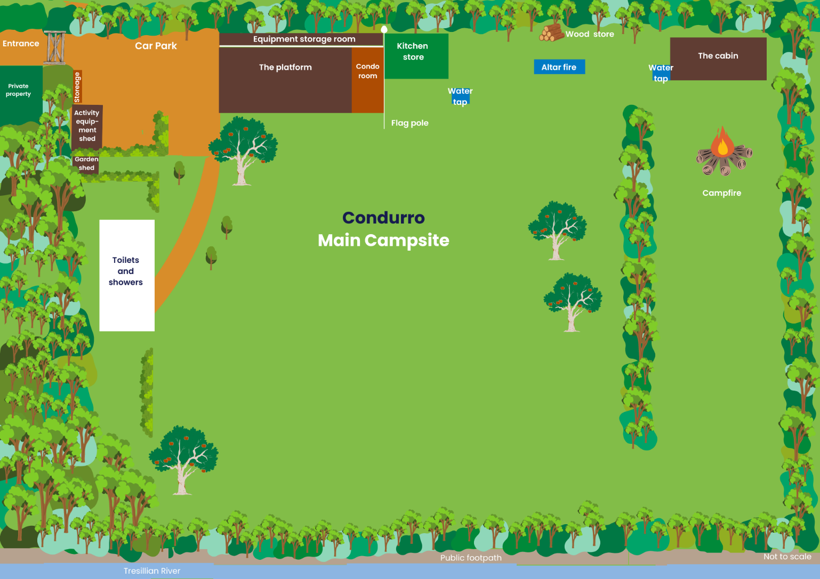​Site map